Greenvale School - Key Stage 3

Welcome to Greenvale School! We are very much looking forward to working with you and your sons/daughters over the coming years.

Key Stage 3 staff
Liz – Deputy Headteacher
Liz oversees education and the pastoral support of students in KS3, alongside a KS3 coordinator. Although the class teacher is the first point of call, Liz can be contacted if you have a concern about your son/daughter.
Steph – KS3 Learning Mentor
Steph is here to support positive interventions and to help students in a crisis. She works with students to build trust and confidence, and helps students learn to manage their behaviour as well as develop appropriate peer friendships.

Dave - Transition Support/HLTA
Dave is a Higher Level Teaching Assistant at Greenvale School. He will be visiting and working with all students in the Summer Term. Dave will then be based with the Year 7 students in September, to support their transition to Greenvale.

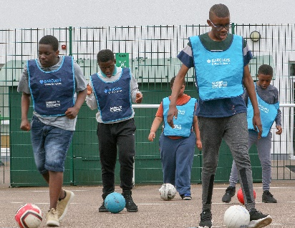
Other key staff
Lynne – Headteacher
Aaron, Lina and Emily – Assistant Headteachers
Ann – Business Manager
Ruth - Admin Officer
Sharna - Admin Officer
Barbara - Senior Admin Officer
Bill – Facilities Manager and transport liaison
Jade, Avita, Carol and Annette – learning mentors.

Organisation
Students are mostly grouped into classes by age and so the classes have a mixed ability range of students from those working at P1- Entry Level 3. Each class has a teacher and 2 support assistants. In KS3 there are currently 3 classes, comprising year groups 7, 8 and 9. It is likely we will have 2 Year 7 classes in September.

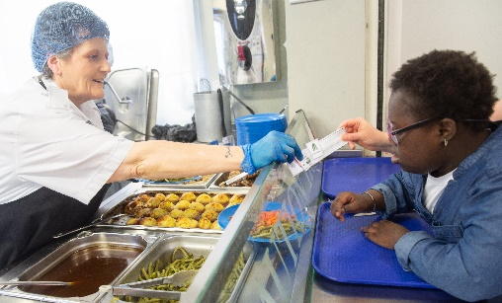
The school day is from 9.15am - 3.00pm. In Year 7 students have a 15min break at 10.30am where juice and fruit are provided, and lunch is served at 11.50am. The kitchen staff are excellent at providing food and drink for all dietary requirements. After lunch students have supervised leisure time with the opportunity to access the main playground alongside other students in KS3. As well as class staff, a Mealtime Supervisor supports the students during this time.
Curriculum
Students in Year 7 generally use a differentiated cross-curricular approach, and have one class teacher. Students in Year 8 and Year 9 follow a differentiated National Curriculum where subjects are taught individually. There are Advance Learner ability groups each week in English and Maths for students who work above P levels. There is also a weekly PE group where students have the opportunity to swim or do PE in the school hall. Students will participate in a weekly whole school assembly about a variety of topics including Religious Festivals. There are a variety of specialist teaching rooms including ICT, Music, Art, Life Skills, Science and the Interactive Room.
LSB
Our ‘Learning Support Base’ provides support for students with profound and multiple learning difficulties on our Grove Pathway. This involves 1:1 and small group sessions, focussing on switch work and communication, as well as physio and hydrotherapy.

iBase
Our Interventions Base involves short term group or individual work for students on the Forest or Woodland Pathways. Interventions can include phonics, maths, support for HI, or social skills.

Assessment
When students arrive at Greenvale, staff complete baseline assessments of their abilities in all areas including personal skills and academic skills. Students are assessed using P Levels, Greenvale Levels and Functional Skills Levels. Students will have a mini IEP set in October (2 targets), and full IEPs thereafter (4 targets) per term. Progress reports for IEP targets will be sent home at the end of each term, and a yearly report for all subjects will be sent home in the Summer Term. An Annual Review meeting will be held each year, and there will be parents’ evenings in the Autumn and Summer Term.
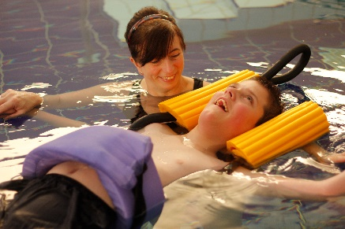
Multi-Disciplinary Team
We have many therapists at Greenvale School to support your son/daughter including Occupational Therapists, Physiotherapists, Speech and Language Therapists and a Music Therapist. We also have a School Nurse and Nursing Support Assistant.

Transition visits
You are welcome to come and visit Greenvale School at any time. Liz is liaising with all the primary schools, and a variety of workshops and tours will be offered throughout the summer term during school hours. Key staff from Greenvale will also visit all Year 6 students.

Contact number: 0208 4650 740
Website: https://www.greenvale.lewisham.sch.uk/website

