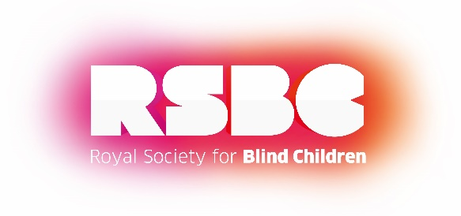
OCTOBER HALF TERM ACTIVITIES WITH RSBC

Tuesday 22nd October - Cycling with Bikeworks, 1:30pm – 3pm
Age: 8-25

Velodrome, Queen Elizabeth Olympic Park, Stratford E20 2ZQ

Join us for an afternoon of cycling. Using a range of adapted cycles including tandem tricycles, side-by-side and platform tricycles, you will explore routes around the Olympic park stadium.

Thursday 24th October – VI Health & Wellbeing Day, 10:00am – 2:30pm
Age: 8-25

Kensington Leisure Centre, Silchester Road, London W10 6EX

Enjoy a day of inclusive sports, crafts and fun activities suitable for visually impaired young people and their families. Our Tech and Employment team will also be there to provide support and advice. There’ll be medals, goodie bags and AQA accreditations up for grabs!

Saturday 26th October – Stubbers Adventure Centre, 11:00am – 3:00pm TBC
Age: 11-25

Ockendon Road, Upminster, Essex, RM14 2TY

Discover a day out with a difference at Stubbers! Enjoy a range of adventurous activities at the outdoor centre and conquer the challenges ahead. You need to be prepared to take part in all activities.

For more information:
E: connections@rsbc.org.uk
T: 0203 198 0225

