January 2022 Parent Survey Results
This survey was sent out to parents via text and Email. Parents were also given the option of a paper copy and invited to contact us if there were any questions they had about the survey. All parents that interacted with the survey did so on line. where a parent disagrees, we felt strongly that we contact that parent and have a conversation. This is for a number of reasons - but mainly so that we can, in the short term, resolve an issue. It also was to make sure that we can learn from what they have to say. We will use that information to inform our actions moving forward and ultimately create better outcomes for our young people.
1. Please State What Key Stage your young person is in.
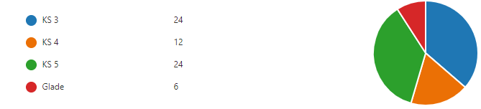
In total there were 80 respondents. This gave us insight into the views of the parents/Carers of 83 students as some have more than one child in our school. This number of responses gave us insight on the provision of 48.2% of the student population.
Looking in more detail at the number of respondents gives us a crude insight into parental engagement across the school using responses by KS as a marker. These results are in line with what we have seen historically. Levels of engagement are high when students enter the school and also when they prepare to move on. Transitions in and out of Greenvale School engages parents for a number of reasons. Having had informal conversations with parents, they have stated that they are invested in their young person settling in well and also the reciprocal building of relationships amongst school staff and parents. Parents of students in KS5 are engaged because of the work that is done with the planning of post Greenvale provision. This process takes place for an extended period of time, with conversations, transition planning and the passing on of information happening throughout the student’s last year here, and in some cases, before. Great care is taken with managing transitions in and out of Greenvale to ensure Student’s needs are met.
Moving forward, and using this theory to predict future levels of parental engagement, we may see an uplift within KS 4 as there will be an additional transition from the Waters Road Site to the Mayo Road site. Learning from transitions into KS3 and out of KS5 will be used to ensure that the process of transition will be successful for our learners.

2. My child is happy at this school
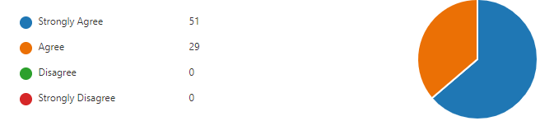
All parents strongly agreed or agreed with this statement. It is worth mentioning that the greatest proportion of respondents strongly agreed. We take great care in ensuring all students are happy. We work hard in ensuring that students have meaningful experiences throughout their time at Greenvale School. Our curriculum, our focus on ensuring a positive environment and our constant striving for the best outcomes for all of our young people means that students are happy. We do this whilst celebrating the individuality of each of our young people – and parents can clearly see this.

3. My child feels safe at this school
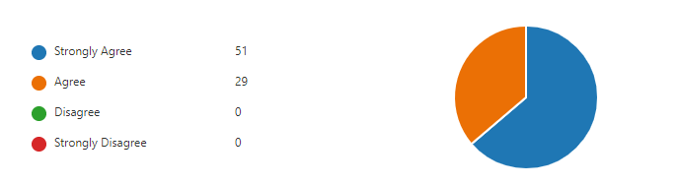
The results show that all the parents that responded feel that their child is safe at Greenvale School. We have robust and effective safeguarding procedures. We also have a strong PSHE curriculum where students are taught about self-advocacy, personal safety and the world around them. It is worth mentioning that this is not the only way in which such skills and knowledge is extended to our young people. Throughout their school day and beyond, we promote safety and awareness. We also offer information and workshops to parents to allow them to gain skills and understanding around child safety and safeguarding. Examples of this are opportunities to attend Internet safety workshops, letters home with information and we also directly work with parents and outside agencies to ensure our young people are safeguarded.

4. The school makes sure its pupils are well behaved
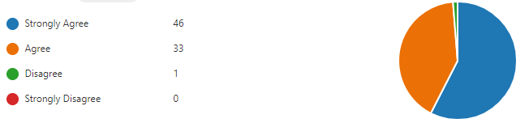
All but one of our parents agreed or strongly agreed with this statement. Only one disagreed. As mentioned before, it was important that a conversation was had. It transpired that the parent was referring to their own child as there were some challenges around their behaviours. This particular young person is now doing extremely well and the strategies that were put into place have been highly effective in allowing that young person to manage their own behaviour.
Greenvale school has a strong ethos around students being able to self-manage their behaviour as much as they can. This ensures that the benefits are felt outside of school because the skills and strategies taught to students can be used in a range of contexts. We feel passionately about this as we take our role seriously in enriching the lives of our young people, giving them the relevant skills to be successful, and for them to be able to access experiences and opportunities in the community presently and later on in life

5. I feel confident that school would deal with the bullying quickly and effectively
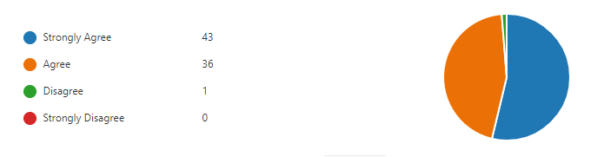
6. My child has not been bullied
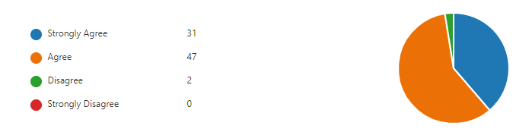
I thought that it would be most useful to review these questions together (5&6). All of our parents agreed or strongly agreed apart from one in the first question and two in the second. We were aware of what the reason might be but still thought it important to have a conversation to recognise their views. The second person on the second question answered the question in error. The first person on each of the questions that disagreed was the same respondent. This incident was almost two years ago and has been resolved. The student who displayed the behaviours that were experienced and interpreted as bullying has since moved on to college. The student involved has complex SEMH challenges and we worked with that student and the student that was identified as being bullied. The issue was quickly resolved and the students were able to move forward with help and support. Where bullying is suspected, we ensure that it is looked into and resolved as quickly and as effectively as possible. We also make sure that students are aware of their behaviours and the impact it might have on others. As well as this, we promote and teach resilience and encourage students to speak out and talk about issues. All of these measures ensure that bullying at Greenvale School is extremely rare.

7. When I have raised concerns with the school they have been dealt with properly
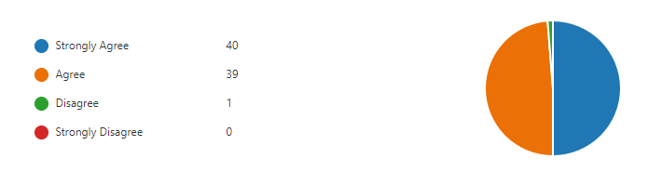

All but one of our parents agree or strongly agree. The one parent that disagreed was the same parent that had concerns around their own young person’s behaviour in a prior question. Their answer is related to this. As previously mentioned, the young person is doing very well and concerns were historical, but the parent wanted this to be recognised all the same. Overall, the results are very positive. We ensure that we communicate to parents that their views, opinions and thoughts are valued. We have an open dialogue with parents and ensure we are approachable as an organisation. It is because of this that parental concerns are mostly raised while they are small and easy to resolve. We have set procedures and a complaints policy that we follow.

8. The school makes me aware of what my child will learn during the year
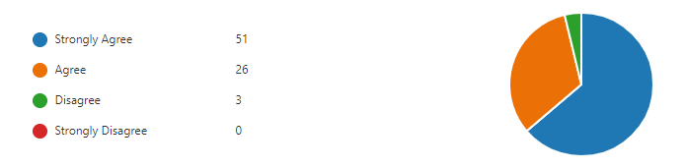
The overall response to this question is positive. Parents feel that we communicate this to them effectively. This is done through home school books, regular phone calls, formal and informal feedback. Students have individual time tables and these are shared with parents at the beginning of the year. The curriculum map is available on the website alongside other key information. Regardless of this, three parents have indicated that their experience is different. We have looked into how we might improve how we share information about what students will learn. We will send out a list of topics being studied each term. In the longer term, we will share a brief overview of the subject content within the topics being studied so that parents can have a better understanding of their children’s learning.

9. My child has SEND, and the school gives them the support they need to succeed
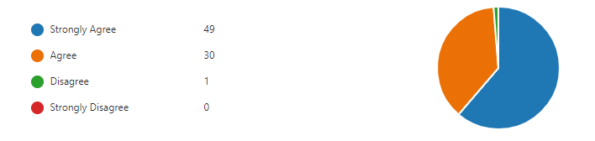

All parents agreed or strongly agreed. The one parent that did not went on to explain in another answer that due to Covid, they have not been able to get into the school to see around and therefore they were not able to make a qualified assessment in order to answer the question. As there is no option for I don’t know – they chose to disagree. Overall, this was a positive response.

10. My child does well at this school
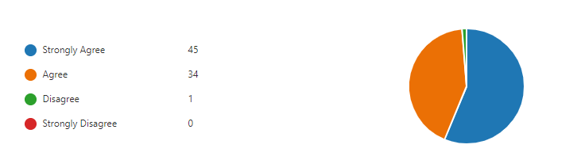

All bar one of the respondents say that their young person does well. Again, the one parent that disagrees does so because there is not an option for do not know. They explained that they do not know this because their young person has not been in the school long enough for them to make that decision. The result is positive and we ensure all of our young people are supported in being successful. We track and monitor the progress our young people make across the curriculum. We also support them in other areas such as their wellbeing and social skills.

11. The school lets me know how my child is doing
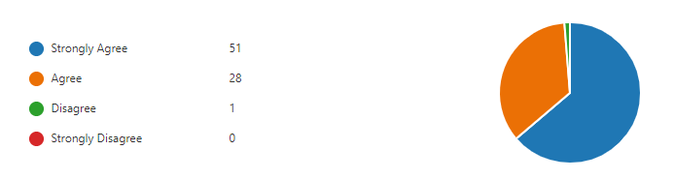
All parents indicated though their answer that we communicate with them well. There was one parent that disagreed and we called to seek further insight into their answer. It turned out that this answer was in error. We have regular contact with our parents and carers. Teachers update on student progress through the home school book and also via the telephone. KS co-ordinators and learning mentors are also in regular contact with parents and families offering regular support and information. These are in addition to more formal opportunities such as parents’ evening as EHCP reviews.

12. There is a good range of subjects available to my child at this school
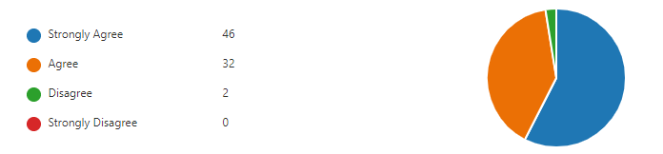
At Greenvale School we follow the full curriculum. We take great care ensuring its design and delivery meets the needs of the individual and through our pathways, we ensure it is relevant and enriching. Each student has the opportunity to engage and learn practical skills, independence and self-help strategies. Teachers and support staff have excellent and productive relationships with our young people and they strive to make sure curriculum is geared towards the diverse and individual needs of our young people. Two parents disagreed with the statement. One (as before) felt that their young person had not been in the school long enough for them to make a decision. Moving forward and as mentioned in the analysis of question 8, we will share more information with parents informing them more regularly on the subjects and topics their young people are accessing.

13. My child takes part in a good range of enriching activities at school.
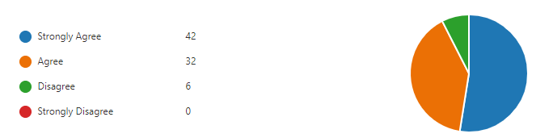
All students have access to a range of activities in school throughout the school year. These are delivered though the curriculum and also as discrete opportunities. Enrichment opportunities are tracked and monitored to ensure that all students have a good level of provision. A number of parents disagreed with this statement. Some, as in other questions, felt their young people had not been at Greenvale School long enough to give an answer. Because of this, they disagreed. Two others felt that although overall communication with parents was good; we have not effectively communicated information on the enriching activities that their young people have been involved in. At present, this is included in the end of year report. Moving forward, we will ensure this is done more regularly and teachers will be encouraged to do this in the home school book as and when they happen.

14. The school supports my child’s wider personal development
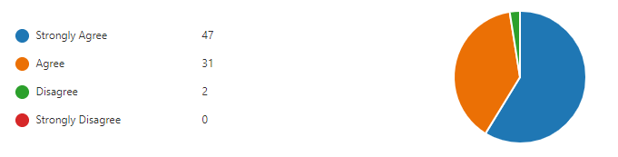
Through the schools enriched and diverse curriculum, the skills of our staff and our overall ethos, we ensure that personal development is threaded throughout our provision. We take our role in ensuring our young people are successful, confident and can self-advocate very seriously. This is important for any young person. However, it is worth mentioning that with the demographics of our cohort, we take extra care in developing such skills. A seemingly small improvement in our young people’s personal development will have a large and positive impact on their and their family’s lives. The two parents that disagreed did so because, as in previous answers, they felt their young person had not been here long enough to feel as though they could agree

15. I would recommend this school to another parent
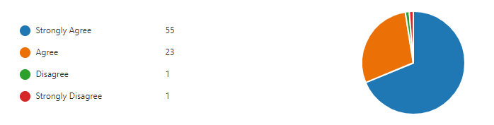
The answers parents gave were extremely positive. One parent disagreed because their young person had only been in the school for a short while. The parent that strongly disagreed did so because they said they know no one with a young person that has the level of need that would mean that their young person would need to access an SLD provision.
16. What are our greatest strengths?
communication with parents, always willing to listen or assist in whatever way they can. Exceptional pastoral care. Excellent leadership
The way you teach and communicate with children. My son is happy to learn and always looks forward to coming to school.

Good communication. Good feedback. Updates, positive activities. Good staffing and diversity.

The teacher gives me daily updates about XXXX what she did at school today. I really appreciate this. They are so helpful and always there for any concerns I have. A big thank you for XXXX. class teacher and other staff members.

Excellent teachers and senior leadership team. Individualised education as much as possible. Good communication and caring staff.

Keeping in touch with the parents and updating them often about the student, making sure student get good education , keeping students safe

Attention to details, Dedication, Creativity, Trustworthy, Respectful, Determination, Patience, Open minded, Flexibility and discipline.

Very good environment. Staff work above and beyond to ensure children are engaged with learning. Head teacher. Deputy head. Head of year all are very good at giving support, feedback and ensuring your child is safe and happy lovely environment for children with disabilities.

Encouraging and supporting our young people to be the best they can be.
. Keeping in touch with the parents and updating them often about the student, making sure student get good education , keeping students safe

The high expectations you have for pupils, no matter their ability.

Wide range of extra-curricular activities.
Experienced and dedicated teachers.
Adequate learning resources and other facilities.
.

Taking/treating every child as an individual as well as not be compliant of children situation
.

We're Happy with Everything so far, things are progressing positively
.

We are really happy with what the parents have shared with us. Obviously the question encourages the parents to share positive aspects of our provision. However, what they say shows the school in a very positive light.

17. What could we do to improve? & 19. What are the three most important issues we should address over the next year.

Extra activities such as swimming lessons as my son only get the opportunity to attend swimming only on Saturday.

Nothing

Nothing

I think the school does an excellent job. Maybe provide more courses for parents.

Allow new parents to view classes & assemblies & see the school in action. Have parents as wider community with PTA or friends’ association. Maybe some parent coffee morning & support sessions. More constant staff & notifying parents about changes. Working with mainstream schools to socialise children.

I think the school does an excellent job. Maybe provide more courses for parents.

Maybe offer chat about young person and class work, current teacher with KS coordinator or someone outside the class.
It will be good with both positive and not positive experience. To have someone to speak outside the class.

A little more info on what they do as my child doesn’t tell me anything.

More homework.

Reading books could be sent home.

Having post 19 provision to the same standard as Greenvale.

Nothing

Relaxing rules for parents around the school

My daughter is leaving this year both XXXX and myself have felt very supported through the years really glad I chose Greenvale thanks.

Outings
Occupational therapist being more involve
Parking for parents.

The answers that were given by parents are very encouraging. They show that any improvements parents suggest do not point towards any serious gaps in our provision. The majority things that are specifically mentioned in are related to visiting the building, coffee mornings and parent training. Prior to Covid, these were all things that were done. Because of Covid, we had to scale back and move opportunities such as these online. We hope in the very near future to move back towards a model that allows parents into the building more. However, in addition to this, capacity is an issue as we are very short of space and next year we will have a dedicated community room. This will greatly increase our capacity to improve provision. We will also re-launch our parent association over the course of next academic year. Homework has also been mentioned. Each term, a letter is sent home for parents to indicate that they would like homework for their young people.

18. Is there anything else you would like to add?
I know the school is trying their best in safety, ensure the safety of school is the top priority considering all the predicaments and changes the virus has caused. Making sure that the safety issue at school is not jeopardised

My twin boys are happy and I'm happy with the school no issues

No the school is amazing.
My son is extremely happy attending this school and has helped to improve his personal, social and emotional development.

My child literally runs to school because he loves being there. Thank you for all your efforts.

I would like to thank all the staff for all being amazing.

The school is doing great and I am so happy my son is a part of this amazing school.

Continue to do what you all do best well appreciated

We as parents are Very Happy and appreciated the level of support from staff at this school, communications are Great and professionalism.

We are impressed with how XXXX vocabulary is increasing and how happy he is. We just really want Adam to be encouraged to be the best he can be.

The staff are really nice

At this time, I can find little fault. As my son is new to the school albeit September 2021 start.

Thank you for all the support you have given me and my family.

The reposes from parents were positive. They recognise the effort that has gone into ensuring the needs of students are met against the challenging backdrop of coronavirus.

Summary of results
The overall outcome from the survey has been very positive. All families feel their young people are safe, that their children are happy at our school and would (if appropriate) recommend our school to others. These three things indicate that the view of the parents that we are successful with our provision.
Looking at the answers that some parents have given and during follow up conversations, it is clear that parents have very high expectations of us. This is a good thing. Parents naturally want the best for their young people. We also found it positive that parents felt they could share things with us that they felt would allow us better meet the needs of their young people. This shows that they have faith in us to listen and make changes. It also shows they are engaged with us enough to share such things.
There were a number of themes that were evident throughout the process of analysis. Many of them positive. There were some that gave us useful feedback in relation to what we can do to improve provision – or how we might devise ways to better communicate. They are summarised below:

Theme | How we will improve | Time Frame
Some parents felt that the enrichment offer for their young person could be improved. | Enrichment opportunities are something that we ensure are available to all students across the school. We track and monitor opportunities and know that provision is good. However, we will be more effective at communicating this with parents. | ASAP – We will ask Class Teachers to communicate with parents as and when such activities are afforded to our students. This will be done in the home school book.
Some parents felt that there was not enough opportunity to physically access the school and therefore felt there were gaps in their knowledge about our provision. | This is something that sadly has been out of our hands. We are an extremely open organisation and welcome parental engagement. However, due to COVID, we have been unable to offer that level of openness that parents are accustomed to. Moving forward, and as things get better, we will move back towards being open welcoming people on site. | We have started already, and will continue to do so in line with guidance.
A number of parents mentioned that they would like home work. | Homework is available to those that what it. Letters are sent out at the beginning of each term. In addition to this we will look into sending out a text when the letter goes out reminding parents to return the letters. | This will be completed by the 2nd week of the summer term.
What is studied at school could be communicated more regularly. | We communicate well with parents though a variety of means. The curriculum map is on the website and student individual time tables were sent out at the beginning of the year. Moving forwards, we will routinely send out a copy of the curriculum map that each student will be following for that term and include a copy of that young person’s individual time table. | This will be completed by the 2nd week of the summer term.

