Labour Market Information

Labour Market Information (LMI) is a useful tool to help research future jobs in the local area, understand the skills needed for certain roles and the demand for future employment.
LMI tends to focus on the industries that are growing and declining. It provides information about the types and levels of jobs and the skills required and whether they are increasing or decreasing.
LMI effectively describes the world of work – it ranges from descriptions of different careers, their entry routes, promotional prospects, salaries paid, skills and qualifications needed, etc. It is crucial for young people as LMI also covers future demand – what kinds of jobs will be in demand after leaving school and what kinds of skills will be needed which will ultimately optimise their life chances.
You can check the poster below to find out what is happening in the labour market in London and South East London:

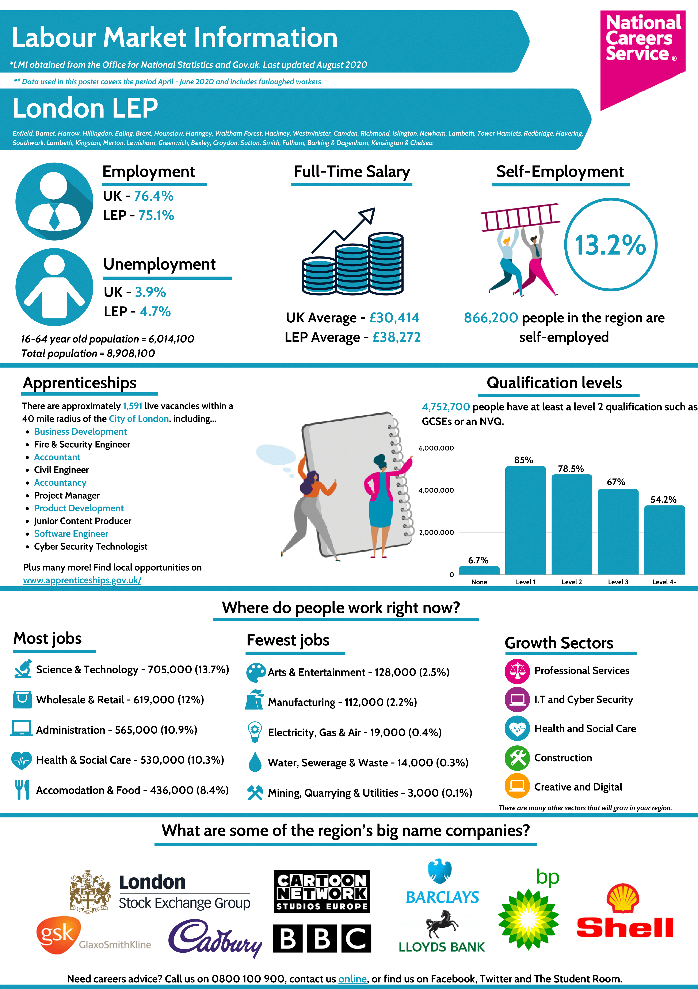

Students, parents/carers, and school staff have access to up-to-date labour market information at Greenvale School and access to a variety of different jobs and professions offering.
There are different websites for students, parents/carers, and school staff to obtain information in labour market. Students, parents/carers, and school staff can use Start Profile’s, ‘Explore’ section to browse for jobs based on their interests, strengths, subject preferences, or jobs that are in demand.
You can click on the links below to get up-to-date information on job vacancies.

- Students can click on https://london-lmi.startprofile.com/page/home-page
- Parents/ carers can click on https://careers.startprofile.com/page/parents
- School staff can click on https://london-lmi.startprofile.com/page/regional-teacher-overview

You can also click on the link https://nationalcareers.service.gov.uk/ to obtain information on other career sectors from the National Careers Website.

LMI also provides students with time for reflection when choosing their next steps after school or college. For some students, going to college may be the only option to break into the industry, whereas for others, an apprenticeship may provide equal opportunities. This enables young people, parents/carers, and school staff to fully consider their options and to decide based on what is right for them, connected with their career aspirations.
You can click on the link below to obtain more information about apprenticeships:
https://amazingapprenticeships.com/about-ask/

Students from Greenvale School, however, have received the support from Project Search that provides supported internships to young people with SEND. You can get more information clicking in the link https://www.dfnprojectsearch.org/.

Lewisham College and London South East Colleges also provide support and information for apprenticeships where our students can attend after finishing school. You can check their websites for more information:

- https://www.lewisham.ac.uk/courses/supported-learning
- https://www.lsec.ac.uk/courses/send/457-entry-level/1530-employment-preparation-pathway-entry-level-certificate

LMI also offers two widgets that allow students, parents/carers, and school staff to explore labour market information.
The Skillsometer can be accessed by clicking on https://www.icanbea.org.uk/skills-o-meter/. Skillsometer has been designed to help those students to discover what jobs they might like to do in the future as they are not sure about what job they may be interested in. The widget helps you think about skills, interests, and the ways these can link to jobs as a helpful first step in identifying possible future jobs.

The Careerometer can be accessed by clicking on https://careermap.co.uk/careerometer/.
The Careerometer provides up-to-date labour market information about both the UK workforce in general and for specific jobs providing information about weekly and annual pay of job roles in the UK that you are interested in.

